2nd July 2021 www.tfwm.org.uk/sprint

Notice of Sprint works on A45 |  | Duration of works  Work will take place overnight on Friday 16th July. Please note that times may be subject to change.  What to expect  An overnight closure of the A45 between Forest Road and Kings Road.  Work will take place between 8pm and 6am.  Expect some noise from on-site vehicles.  Pedestrian access will be maintained at all times.  What we will do  We’ll keep all sites safe and secure, keeping disruption to a minimum and ensure all traffic management signs are clearly displayed.  How to contact us  call: 07583 132983  email: Enquiries.sprintA45 @morgansindall.com  web: tfwm.org.uk/sprint  twitter: @transportforwm  Please contact us if you require this notification to be provided in an alternative format or in a different language.
Removal of traffic restrictions on Coventry Road
Sprint is a priority bus corridor joining the A34 with the A45 to create one continuous route. The main construction work along the A45, is being carried out by Morgan Sindall Infrastructure on behalf of Transport for West Midlands (TfWM).
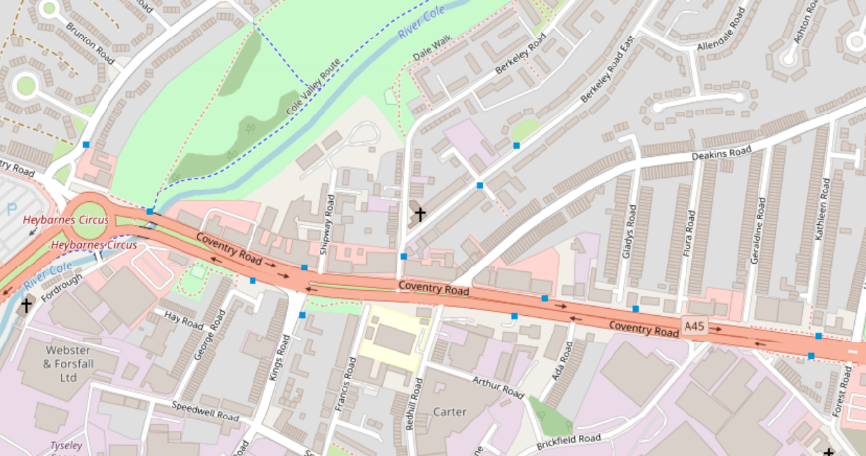
We will be carrying out the removal of traffic management measures - such as traffic cones and barriers - between Swan Island and Heybarnes Circus from the junction of Forest Road and Kings Road. This will require a full overnight closure of the Coventry road on the inbound carriageway towards Birmingham city centre between 8pm on the 16th July and 6am on 17th July 2021.
Overnight closure of the A34 towards Birmingham city centre between Forest road and Kings road.
Map data © OpenStreetMap contributors CC-BY-SA. Indicative only.

Please contact us if you require further information.
The Sprint corridor will link Walsall with the centre of Birmingham, Solihull and Birmingham Airport. It will bring benefits for all bus passengers by providing more reliable, regular and predictable journey times, connecting our region and protecting our environment.

