28th June 2021 www.tfwm.org.uk/sprint

Notice of Sprint works on A45 |  | Duration of works  Further continued closure of Brickfield road until Friday 16th July. Please note that times may be subject to change.  What to expect  - Traffic restrictions  - Work will be carried out during the day and overnight.  - You will experience noise from onsite machinery  - access to businesses at all times  What we will do  We’ll keep all sites safe and secure, keeping disruption to a minimum and ensure all traffic management signs are clearly displayed.  How to contact us  call: 07583 132983  email: Enquiries.sprintA45 @morgansindall.com  web: tfwm.org.uk/sprint  twitter: @transportforwm  Please contact us if you require this notification to be provided in an alternative format or in a different language.
Brickfield Road junction upgrade

Sprint is a priority bus corridor joining the A34 with the A45 to create one continuous route. The main construction work along the A45, is being carried out by Morgan Sindall Infrastructure on behalf of Transport for West Midlands (TfWM).
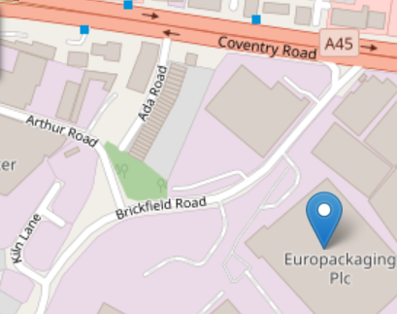
We are extending our works to upgrade the junction with the A45 and Brickfield Road and this requires a further full closure of Brickfield road during the day and overnight until Friday 16th July 2021. We will continue to provide access for affected businesses and a diversion route will remain in place.
Full closure of Brickfield Road until Friday 16th July
Map data © OpenStreetMap contributors CC-BY-SA. Indicative only.

Please contact us if you require further information.
The Sprint corridor will link Walsall with the centre of Birmingham, Solihull and Birmingham Airport. It will bring benefits for all bus passengers by providing more reliable, regular and predictable journey times, connecting our region and protecting our environment.

