June 2021 www.tfwm.org.uk/sprint

Notice of Sprint works on A34 at Bridge Street |  | Duration of works  Work is expected to begin from Thursday 15th July and last for up to four weeks.  Please note that times may be subject to change.  What to expect  Work will take place from Monday – Friday between 8am and 5pm.  Temporary closure of the Bridge Street bus stop in Walsall town centre for the duration of these works.  Access to properties will be maintained at all times.  Expect some noise from on-site machinery.  What we will do  We’ll keep all sites safe and secure, keeping disruption to a minimum and ensure all traffic management signs are clearly displayed.  How to contact us  call: 0345 303 6760, option 2, then option 3  email: sprintenquiries@ tfwm.org.uk  web: tfwm.org.uk/sprint  twitter: @transportforwm  Please contact us if you require this notification to be provided in an alternative format or in a different language.
Utility works for new shelter installation

Sprint is a cross city bus priority corridor joining the A34 with the A45 to create one continuous route.
We will be installing new and enhanced bus shelters along the corridor to improve passenger safety and comfort. The new shelter design is a little larger than standard bus stops and will include CCTV cameras. All new shelters meet the Local Authority’s highway safety criteria.
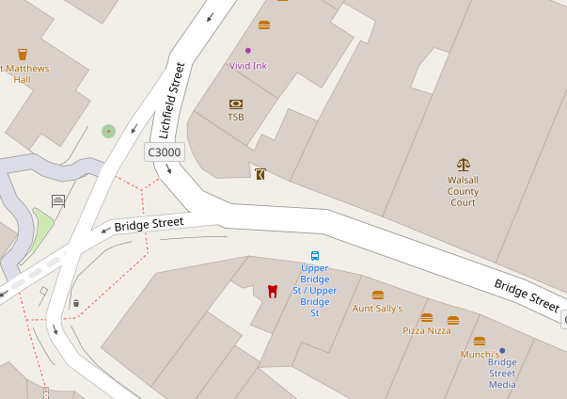
The work will be carried out in three phases beginning with the removal of the existing shelter. Utilities – such as communications cabling – will either be relocated or replaced followed by a temporary reinstatement of the footway and shelter area. The new shelter will then be installed at a later date as part of other works in the area.
Map data © OpenStreetMap contributors CC-BY-SA. Indicative only.
Temporary closure of the Bridge Street bus stop in Walsall town centre for up to 4 weeks.

The Sprint corridor will link Walsall with the centre of Birmingham, Solihull and Birmingham Airport. Sprint will join with other schemes such as the Midland Metro and HS2 to create a truly integrated network. The first phase is due to open in 2022 in time for the Commonwealth Games.

