August 2021 www.tfwm.org.uk/sprint

Notice of Sprint works on A45 Coventry Road |  | Duration of works  Work is expected to begin from Monday 16th August and last for up to three weeks.  Please note that times may be subject to change.  What to expect  Work will take place at the Lyndon Road bus stop towards Birmingham from Monday to Friday between 8am and 5pm, though traffic management will be in place 24hrs a day.  Access to properties will be maintained at all times.  Expect some noise from on-site machinery.  What we will do  We’ll keep all sites safe and secure, keeping disruption to a minimum and ensure all traffic management signs are clearly displayed.  How to contact us  call: 0345 303 6760, option 2, then option 3  email: sprintenquiries@ tfwm.org.uk  web: tfwm.org.uk/sprint  twitter: @transportforwm  Please contact us if you require this notification to be provided in an alternative format or in a different language.
Utility works for new shelter installation

Sprint is a bus priority corridor joining the A34 with the A45 to create one continuous route.
In this location we will be installing a new bus shelter and amended pedestrian crossing to improve passenger and pedestrian safety and comfort. The new shelter is a little larger than standard bus stops and will include CCTV cameras. All new shelters will meet the Local Authority’s highway safety criteria.
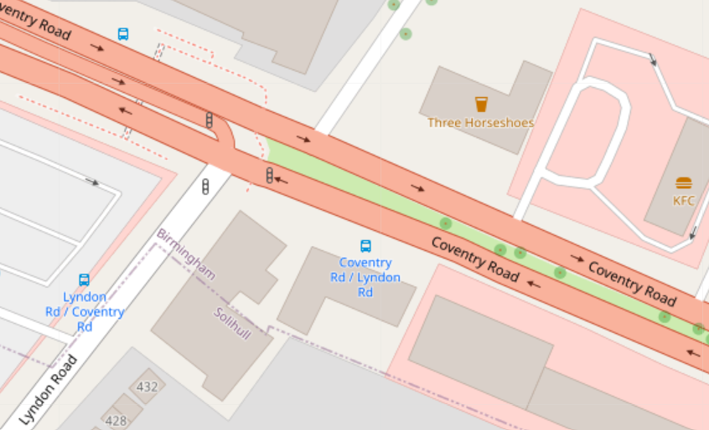
The work will be carried out in three phases. Utilities – such as communications cabling – will either be relocated or replaced followed by a temporary reinstatement of the footway and shelter area. A temporary bus stop will be provided for the duration of the works. The new shelter will then be installed at a later date as part of other works in the area.
Work will take place at the Lyndon Road bus stop on the A45 towards Birmingham and last for up to three weeks.
Map data © OpenStreetMap contributors CC-BY-SA. Indicative only.

The Sprint corridor will link Walsall with the centre of Birmingham, Solihull and Birmingham Airport. Sprint will integrate with other schemes such as the Midland Metro and HS2 to create an integrated transport network. The first phase is due to open in the summer of 2022.

